Resumé

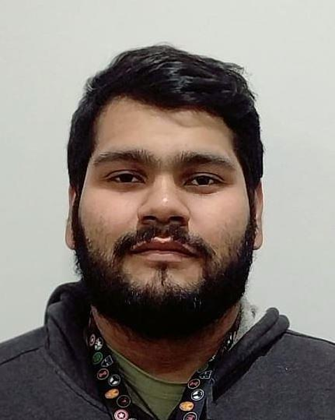

Personal information:

Name: Kevin Francisco Vásquez Grande

Day of Birth: December 3rd 1997

Address: Residencial San Juan Montebello senda A Block 2 #19, Mejicanos

Phone Number: 78724454/2274-6996

E-mail: [kevinvasquez720@gmail.com](mailto:kevinvasquez720@gmail.com)

DUI: 05627831-8

Studies

Elementary/Middle school:

1st - 8th grade (2004 – 2012) - Centro Escolar Dr. Doroteo Vasconcelos

9th (2013) Instituto Técnico Ricaldone

High school (2014 – 2016):

Bachillerato técnico industrial opción sistemas informáticos - Instituto Técnico Ricaldone

College:

2nd year Computer Engineering - Universidad Tecnológica de El Salvador

Skills

* Computer hardware troubleshooting and maintenance
* Customer service oriented
* Effective communication
* Proficient English and Spanish communication

Work Experience

Company: Sykes El Salvador Ltda.

Immediate supervisor: Joaquin Guzman

Phone Number: (503) 70934620

Start: august 21st, 2017 Finished: feb 26th, 2018

Function: tech support agent

Activities: TV’s, blu ray players, projectors & universal remotes tech support for Sony

Company: Sykes El Salvador Ltda.

Immediate supervisor: Kevin Peñate

Phone Number: (503) 77991753

Start: February 26th, 2018 Finished: December 12th, 2018

Function: Customer Service agent

Activities: Flight, hotel and packages reservations for Expedia.com

Company: Telus International El Salvador.

Immediate supervisor: Veyra Garcia

Phone Number: (503) 70229226

Start: January 2nd 2019

Function: Workspace/G Suite Tech support

Activities: UI and Navigation support, general troubleshooting, DNS set up, Email service routing, set up and Migration, calendar and contacts migration, device policy setup, Google Drive, Google Vault and Google voice general troubleshooting.

Personal references

Valeria Ramos  
phone number: 7683-6914

Carlos Garcia   
phone number: 7163-8664

Leyda Gisela de Reyes  
phone number: 7160-2975

